**PART 3: Conversations**

**Directions**: You will hear some conversations between two or more people spoken only one time. The conversations will not be printed in your test book and will be spoken only one time. You will see three questions on each conversation and four possible answers. Choose the best answer to each question and fill in the corresponding oval on your answer sheet.

**32.** What kind of movie will the speakers see?

(A) Romance

(B) Comedy

(C) Action

(D) Drama

**33**. What time will the speakers leave?

(A) 6:00

(B) 6:15

(C) 6:30

(D) 7:00

**34.** What does the man want to do?

(A) Read the reviews

(B) Arrive on time

(C) Take a cab

(D) Eat something

**35.** What is Mrs. Kowalski doing?

(A) Eating

(B) Sleeping

(C) Reading a report

(D) Attending a meeting

**36.** What does the man offer to do?

(A) Schedule an appointment for the caller

(B) Ask Mrs. Kowalski to return the call

(C) Transfer the call to Mrs. Kowalski

(D) Answer the caller’s questions

**37.** When will the caller call again?

(A) At noon

(B) Later this afternoon

(C) Tomorrow morning

(D) Tomorrow afternoon

**38.** How many wedding guests will there be?

(A) Less than 100

(B) More than 100

(C) About 300

(D) More than 400

**39.**What does the man ask the woman to do?

(A) Suggest a menu

(B) Find a new caterer

(C) Send the invitations

(D) Contact the caterer

**40.** What kind of food does the woman want at the wedding?

(A) Fish

(B) Chicken

(C) Vegetarian

(D) Steak

**41.**What does the woman want to do?

(A) Have photos printed

(B) Order some lunch

(C) Buy a film camera

(D) Get a new printer

**42.**How much does the woman have to pay?

(A) $7.00

(B) $11.00

(C) $17.00

(D) $36.00

**43.**Why does the woman say, “Would you”?

(A) To request a favor

(B) To accept an offer

(C) To give some advice

(D) To ask for an explanation

**44.** When did the woman go to the library?

(A) Sunday

(B) Monday

(C) Tuesday

(D) Friday

**45.** What did she do at the library?

(A) Wrote a report

(B) Used the Internet

(C) Searched for books

(D) Read fashion magazines

**46.** How does the man feel?

(A) Hot

(B) Fine

(C) Tired

(D) Sorry

**47.** What is the man’s occupation?

(A) Tour guide

(B) Airplane pilot

(C) Travel agent

(D) Flight attendant

**48.** What will the women do during their trip?

(A) Participate in a conference

(B) Look at houses for sale

(C) Attend a social event

(D) Go shopping

**49.** What does the man mean when he says, “You got it”?

(A) The woman asks too many favors

(B) He will change the date on the tickets

(C) The plane tickets are all ready

(D) The party date is correct

**50.** What does the man tell the woman to do?

(A) Hurry

(B) Get thinner

(C) Put on boots

(D) Change her dress

**51.** How is the weather?

(A) It’s snowing

(B) It’s raining

(C) It’s fine

(D) It’s hot

**52.** Where are the speakers going?

(A) To work

(B) To a show

(C) To a dinner

(D) To the shoe store

**53.** Where are the speakers?

(A) In an office

(B) In a clothes store

(C) In a health club

(D) In an exercise equipment store

**54.** What does the man want to do?

(A) Look around

(B) Take a shower

(C) Get back to work

(D) Try out the equipment

**55.** How can the man get more information?

(A) Call

(B) Read a book

(C) Ask the woman

(D) Go online

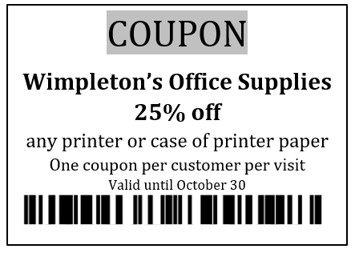

**56.** Who is the man?

(A) A customer

(B) A sales clerk

(C) A store manager

(D) A woman’s boss

**57.** Look at the graphic. Why was the coupon NOT accepted?

(A) It has expired

(B) It is from a different store

(C) It is for purchase over $200 only

(D) It is for items that the customer is not buying

**58.** What will the woman do?

(A) Pay full price

(B) Shop at a different store

(C) Return some of the items

(D) Come back to the store later

**59.** Where are the speakers?

(A) At a concert

(B) At a lecture

(C) At a movie

(D) At a play

**60.** How much did the ticket cost?

(A) $50 each

(B) $100 each

(C) $115 each

(D) $150 each

**61.** What does the woman say about the tickets?

(A) They are not for the seats she wanted

(B) They cost more than she expected

(C) They were not too expensive

(D) They were hard to get

**62.** What did the man order?

(A) Pens

(B) Pencils

(C) Envelopes

(D) Notebooks

**63.** How many did he order?

(A) Four dozen

(B) Five dozen

(C) Four hundred

(D) Five hundred

**64.** When will the order arrive?

(A) Tuesday

(B) Wednesday

(C) On the weekend

(D) Next week

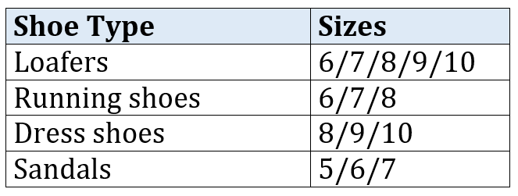

**65.** What are the speakers looking at?

(A) A sporting goods brochure

(B) A fashion magazine

(C) A store catalogue

(D) A newspaper

**66.** Look at the graphic. What types of shoes come in the right sizes for the woman?

(A) No shoes come in suitable sizes

(B) Loafers and dress shoes

(C) Dress shoes and sandals

(D) Sandals only

**67.** What kind of shoes does the man want to buy?

(A) Loafers

(B) Sandals

(C) Dress shoes

(D) Running shoes

**68.** Why does the man have to go to the office early?

(A) To have breakfast there

(B) To attend a meeting

(C) To finish a report

(D) To get ready for a trip

**69.** When will Mr. Park return to the office?

(A) Tonight

(B) Tomorrow morning

(C) Tomorrow afternoon

(D) Tomorrow night

**70.** When does the man plan to leave home?

(A) 4:08

(B) 6:00

(C) 6:30

(D) 8:00